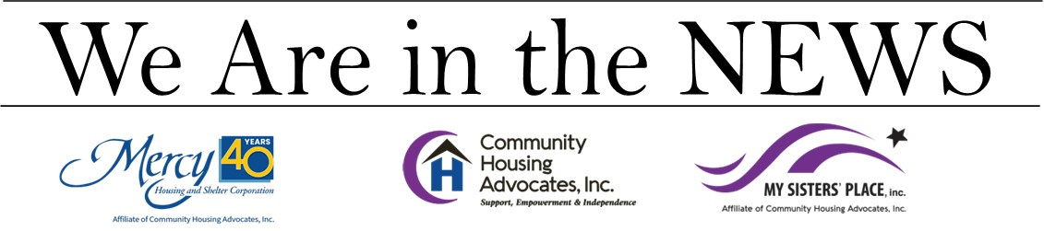
St. Elizabeth’s Featured on Crossroads Magazine Broadcast
May 28, 2023
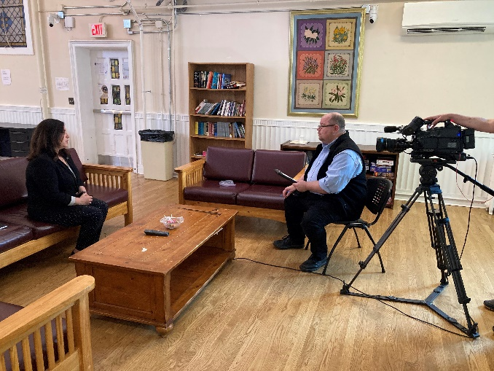 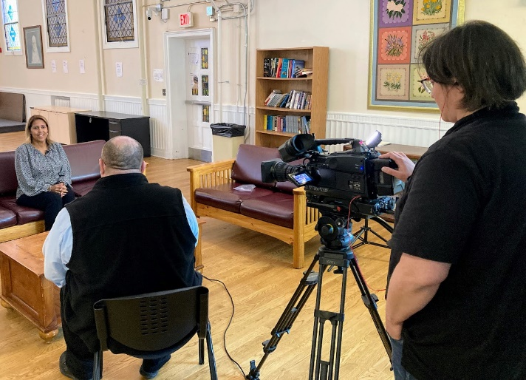

If you tuned-in to Sunday Mass on MvTV9 or Fox 61 on May 28th, you would have seen Fr. John Gatzak introduce a familiar story to you on their televised Crossroads Magazine program.
A television crew from the Office of Radio and Television (ORTV) for the Archdiocese of Hartford spent time interviewing Kara Capone, CEO of Community Housing Advocates and Natalie Cooke, Director of Client Services at Saint Elizabeth House in preparation for a feature story on Mercy Housing and Shelter Corporation.
With the theme of Delivering Hope. Transforming Lives - the four-and-a-half-minute piece touches on Mercy Housing’s 40-years of serving the homeless community, including support for veterans, those with mental illness, women in recovery, those living with HIV/AIDS and more.
To see the segment in its entirety, go to: https://vimeo.com/showcase/7722218 and select the May 28th edition. Our story begins 5-minutes into the program and runs approximately 4.5 minutes.

